Software Requirements Specification

for

Sale Opportunity

**SOP Systems**

Table of Contents

Table of Contents ii

Revision History ii

1. Introduction 1

1.1 Purpose 1

1.2 Document Conventions 1

1.3 Intended Audience and Reading Suggestions 1

1.4 Product Scope 1

1.5 References 1

2. Overall Description 2

2.1 Product Perspective 2

2.2 Product Functions 2

2.3 User Classes and Characteristics 2

2.4 Operating Environment 2

2.5 Design and Implementation Constraints 2

2.6 User Documentation 2

2.7 Assumptions and Dependencies 3

3. External Interface Requirements 3

3.1 User Interfaces 3

3.2 Hardware Interfaces 3

3.3 Software Interfaces 3

3.4 Communications Interfaces 3

4. System Features 4

5. Other Nonfunctional Requirements 4

5.1 Performance Requirements 4

5.2 Safety Requirements 5

5.3 Security Requirements 5

5.4 Software Quality Attributes 5

5.5 Business Rules 5

6. Other Requirements 5

Appendix A: Glossary 5

Appendix B: Analysis Models 5

Appendix C: To Be Determined List 6

Revision History

|  |  |  |  |
| --- | --- | --- | --- |
| **Name** | **Date** | **Reason For Changes** | **Version** |
|  |  |  |  |
|  |  |  |  |

# Introduction

## Purpose

The purpose of this project is to provide the company a organizational ability and efficient way to manage the company transactions, by developing a user-friendly booking management system.

## Document Conventions

In this document topics are listed numerically, every new topic start with big bold font headline and every subtopic start with smaller bold font headline.

## Intended Audience and Reading Suggestions

The intended audience of this document are the client and the development team, the project will be supervised by the project guider.

## Product Scope

The software will provide an adjusted management system to the users of the company,

the Travel agents will have efficient and organized way to manage and access the company data base, And the clients will have an easy and wide functionality user experience.

## References



*SRS template.*

# Overall Description

## Product Perspective

This product is a new system that will generate tracking data base based on the user existing data base of products, as the described below:

**clients**

**Travel agents**

**system**

**packages**

**transictions**

## Product Functions 2.2.1. Add a package

The travel agent will have the ability to add a package to the data base.

### 2.2.2. delete package

The travel agent will have the ability to remove a package from the data base.

### 2.2.3. Track orders

Tracking and sorting orders performed by customers

### 2.2.4 change order status

***2.2.4.1 by agent***

The travel agent will have the ability to change status of an order

***2.2.4.2 by client***

The client will have the ability to cancel an order.

### *2.2.4.* *Order management*

### The agent will have the ability to change the quantity of packages and watch in real time at the updates.

### *2.2.5.* Contact

### Absorption of all details for a contact request

### *2.2.6.* menu

### *2.2.6.1* agent menu

### The agent will have a customized menu.

### *2.2.6.2* client menu

### The client will have a customized menu

## User Classes and Characteristics

There will be two kinds of user's classes agent and client. The agent will have access to all the software features. client will have a more limited number of features. The additional features of the agent are packages management.

## Operating Environment

The system runs on Microsoft Windows 7/8/10 versions 86x and 64 bits.

The system must use a local database, the user will have the ability to manage packages.

## Design and Implementation Constraints

The software depends on high internal memory of the computer, be it RAM or HDD and its permutations. The developer must have access to the employee database. There is a limitation to the usage of its features by different users based on roles (agent/client). Software’s security must be assigned by the customer and customers own programming team as required by its own security protocols. The customers organization will be responsible for Integrating/maintaining the delivered software.

## User Documentation

The user will receive a manual detailing the functionality of the software.

## Assumptions and Dependencies

Our assumption that employee Database will be received from the HR department in ‘.txt’ file which the program will assign 'LOG IN' details of all company agents.

The file will be as follows: First name, Last name, Password, Role. (all on different lines) employees separated by '$' sign

The database includes details of access for each user such as Employee & Manager stated by Role.

# External Interface Requirements

## User Interfaces

The software will have basic menu bar with options, one for agents and one for the clients. - TBD

See the prototype presentation (style may differ from the final product).

## Hardware Interfaces

The application requires a monitor and working computer with OS installed.

## Software Interfaces

The application will have access to data base that was written by a third-party software program (in a .txt format).

The interface is as shown in the prototype.

## Communications Interfaces**

Communication with human resources databases to transfer data into the software.

# System Features

## Description and Priority

* The clients will be able to leave a message to reserve a certain package.
* The agents will be shown processing orders.
* The agents will be able track and recommend packages for potential customers.
* The client will be able to see the availability of the package and how many are left.

### Stimulus/Response Sequences

* There will be an option to rate each package- TBD.
* The software will show recommended packages for the client.
* The client will be able to search packages by different categories (price, location , ect..).
* Clients will be able to see previously searched packages- TBD.

### 4.3Functional Requirements

The user’s workflow will closely follow the sequence of actions shown in the Flow Chart (see Appendix B) be it Employee or Manager.

The error messages will appear as result of incorrect input in each field and briefly explain the error.

* Clients who are yet to be registered will be asked to login to access certain actions.
* Error messages will show for wrong details entered.
* Packages without any quantity left will not be available to order.
* Problems with server overload will be dealt with – TBD
* Entering overlapping details will not be accepted and will give out an error message.

# Other Nonfunctional Requirements

## Performance Requirements

The product must link with the Internet to communicate with 'Money Transfer Applications' such as PayPal and Human resource Databases, hence the main performance requirement is to make a Q&A platform to help the user with communication issues.

## Safety Requirements

The possible loss to damage that could result from the use of the product is by leakage of personal bank details, which is under responsibility of PayPal and other 3rd party secure Money Transfer Apps.

## Security Requirements

The product will contain big Database with personal details of customers. This Internal database will be encrypted to avoid any leakage of those personal details.

## Software Quality Attributes

* The product will be available to every agent of the travel agency company.
* The product is easy to use.
* The software is compact.
* The software is reliable and updated bug fixes.

## Business Rules

* Only a travel agent can change the prices and accesses to all the available packages.
* The client has no ability to access other customer's details and will only be able to see his details and orders.

# Other Requirements

## Appendix A: Glossary

* SRS – Software Requirements Specification
* OS – Operating System
* HR – Human Resources
* RAM – Random Access Memory
* TBD – To Be Defined

**Appendix B: Analysis Models**

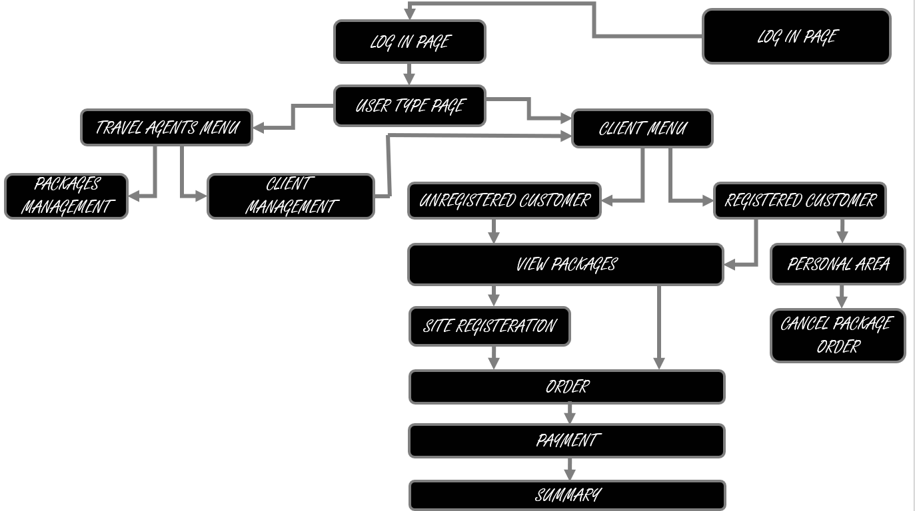

**Appendix C: To Be Determined List**

* Problems with server overload.
* Rating system on packages.